**Class name:** HelpPlace

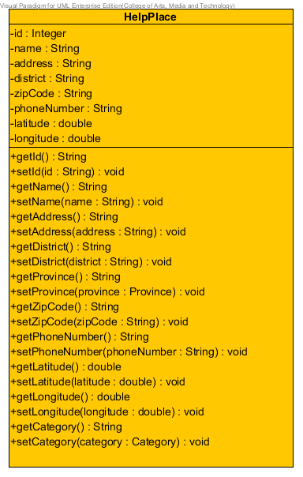

**Entities**

|  |  |  |  |
| --- | --- | --- | --- |
| **ID** | **Name** | **Description** | **Type** |
| 1 | id | stored id of the help place | string |
| 2 | name | stored name of the help place | string |
| 3 | district | stored district of the help place | string |
| 4 | province | stored province object of the help place | Province |
| 5 | zipCode | stored zipcode of the help place | string |
| 6 | phoneNumber | stored phone number of the help place | string |
| 7 | latitude | stored latitude of the help place | double |
| 8 | longitude | stored longitude of the help place | double |
| 9 | category | stored category object of the help place | Category |

**Class name:** HelpPlaceDAO

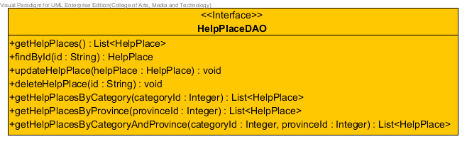

**Method details**

**Method name:** getHelpPlaces

public List<HelpPlace> getHelpPlaces ( )

**Description:** get help places from the database.

**Return:** List of the help place in database.

**Method name:** findById

public HelpPlace findById ( String id )

**Description:** get help place from the database.

**Parameter:** id-String uses for getting the help information.

**Return:** The help place in database.

**Method name:** updateHelpPlace

public void updateHelpPlace ( HelpPlace helpPlace )

**Description:** update information of the help place to database.

**Parameter:** helpPlace-HelpPlace uses for update information of the help place to database.

**Method name:** deleteHelpPlace

public void deleteHelpPlace ( String id )

**Description:** delete the help place from database.

**Parameter:** id-String uses for delete the help place from database.

**Method name:** getHelpPlacesByCategory

public List<HelpPlace> getHelpPlacesByCategory (Integer categoryId)

**Description:** get help places from the database by selected category id.

**Parameter:** categoryId -Integer uses for getting the help place from database.

**Return:** List of the help place in database.

**Method name:** getHelpPlacesByProvince

public List<HelpPlace> getHelpPlacesByProvince(Integer provinceId)

**Description:** get help places from the database by selected province id.

**Parameter:** provinceId -Integer uses for getting the help place from database.

**Return:** List of the help place in database.

**Method name:** getHelpPlacesByCategoryAndProvince

public List<HelpPlace> getHelpPlacesByCategoryAndProvince (Integer categoryId, Integer provinceId)

**Description:** get help places from the database by selected category id and province id.

**Parameter:** provinceId –Integer and categoryId-Integer uses for getting the help place from database.

**Return:** List of the help place in database.

**Class name:** HelpPlaceDAOImpl

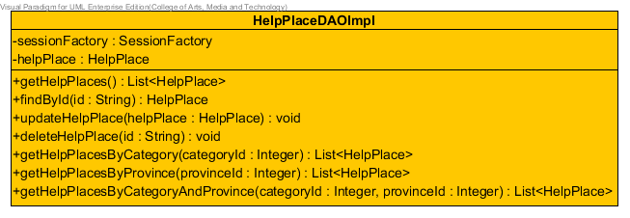

**Entities**

|  |  |  |  |
| --- | --- | --- | --- |
| **ID** | **Name** | **Description** | **Type** |
| 1 | sessionFactory | A thread-safe, immutable cache of compiled mappings for a single database | SessionFactory |
| 2 | helpPlace | Contained HelpPlace class for using method | HelpPlace |

**Method details**

**Method name:** getHelpPlaces

public List<HelpPlace> getHelpPlaces ( )

**Description:** get help places from the database by using session to query data.

**Return:** List of the help place in database.

**Method name:** findById

public HelpPlace findById ( String id )

**Description:** get help place from the database by using session to query data.

**Parameter:** id-String uses for getting the help information.

**Return:** The help place in database.

**Method name:** updateHelpPlace

public void updateHelpPlace (HelpPlace helpPlace)

**Description:** update information of the help place to database by using session to query data.

**Parameter:** helpPlace-HelpPlace uses for update information of the help place to database.

**Method name:** deleteHelpPlace

public void deleteHelpPlace ( String id )

**Description:** delete the help place from database by using session to query data.

**Parameter:** id-String uses for delete the help place from database.

**Method name:** getHelpPlacesByCategory

public List<HelpPlace> getHelpPlacesByCategory (Integer categoryId)

**Description:** get help places from the database by selected category id and using session to query data.

**Parameter:** categoryId -Integer uses for getting the help place from database.

**Return:** List of the help place in database.

**Method name:** getHelpPlacesByProvince

public List<HelpPlace> getHelpPlacesByProvince(Integer provinceId)

**Description:** get help places from the database by selected province id and using session to query data.

**Parameter:** provinceId -Integer uses for getting the help place from database.

**Return:** List of the help place in database.

**Method name:** getHelpPlacesByCategoryAndProvince

public List<HelpPlace> getHelpPlacesByCategoryAndProvince (Integer categoryId, Integer provinceId)

**Description:** get help places from the database by selected category id and province id and using session to query data.

**Parameter:** provinceId –Integer and categoryId-Integer uses for getting the help place from database.

**Return:** List of the help place in database.

**Class name:** HelpPlaceService

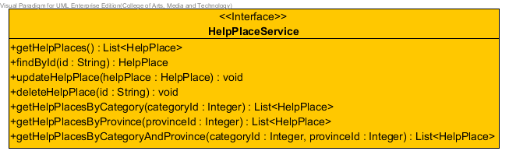

**Method details**

**Method name:** getHelpPlaces

public List<HelpPlace> getHelpPlaces ( )

**Description:** get help places from the database.

**Return:** List of the help place in database.

**Method name:** findById

public HelpPlace findById ( String id )

**Description:** get help place from the database.

**Parameter:** id-String uses for getting the help information.

**Return:** The help place in database.

**Method name:** updateHelpPlace

public void updateHelpPlace (HelpPlace helpPlace)

**Description:** update information of the help place to database.

**Parameter:** helpPlace-HelpPlace uses for update information of the help place to database.

**Method name:** deleteHelpPlace

public void deleteHelpPlace ( String id )

**Description:** delete the help place from database.

**Parameter:** id-String uses for delete the help place from database.

**Method name:** getHelpPlacesByCategory

public List<HelpPlace> getHelpPlacesByCategory (Integer categoryId)

**Description:** get help places from the database by selected category id.

**Parameter:** categoryId -Integer uses for getting the help place from database.

**Return:** List of the help place in database.

**Method name:** getHelpPlacesByProvince

public List<HelpPlace> getHelpPlacesByProvince(Integer provinceId)

**Description:** get help places from the database by selected province id.

**Parameter:** provinceId -Integer uses for getting the help place from database.

**Return:** List of the help place in database.

**Method name:** getHelpPlacesByCategoryAndProvince

public List<HelpPlace> getHelpPlacesByCategoryAndProvince (Integer categoryId, Integer provinceId)

**Description:** get help places from the database by selected category id and province id.

**Parameter:** provinceId –Integer and categoryId-Integer uses for getting the help place from database.

**Return:** List of the help place in database.

**Class name:** HelpPlaceServiceImpl

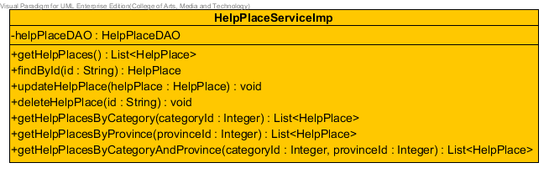

**Entities**

|  |  |  |  |
| --- | --- | --- | --- |
| **ID** | **Name** | **Description** | **Type** |
| 1 | helpPlaceDAO | Contained HelpPlaceDAO class for using method | HelpPlaceDAO |

**Method details**

**Method name:** getHelpPlaces

public List<HelpPlace> getHelpPlaces ( )

**Description:** get help places from the database through getHelpPlaces method of HelpPlaceDAO class.

**Return:** List of the help place in database.

**Method name:** findById

public HelpPlace findById ( String id )

**Description:** get help place from the database through getHelpPlace method of HelpPlaceDAO class.

**Parameter:** id-String uses for getting the help information.

**Return:** The help place in database.

**Method name:** updateHelpPlace

public void updateHelpPlace ( HelpPlace helpPlace )

**Description:** update information of the help place to database through updateHelpPlace method of HelpPlaceDAO class.

**Parameter:** helpPlace-HelpPlace uses for update information of the help place to database.

**Method name:** deleteHelpPlace

public void deleteHelpPlace ( String id )

**Description:** delete the help place from database through deleteHelpPlace method of HelpPlaceDAO class.

**Parameter:** id-String uses for delete the help place from database.

**Method name:** getHelpPlacesByCategory

public List<HelpPlace> getHelpPlacesByCategory (Integer categoryId)

**Description:** get help places from the database by selected category id through getHelpPlacesByCategory method of HelpPlaceDAO class.

.

**Parameter:** categoryId -Integer uses for getting the help place from database.

**Return:** List of the help place in database.

**Method name:** getHelpPlacesByProvince

public List<HelpPlace> getHelpPlacesByProvince(Integer provinceId)

**Description:** get help places from the database by selected province id through getHelpPlacesByProvince method of HelpPlaceDAO class.

**Parameter:** provinceId -Integer uses for getting the help place from database.

**Return:** List of the help place in database.

**Method name:** getHelpPlacesByCategoryAndProvince

public List<HelpPlace> getHelpPlacesByCategoryAndProvince (Integer categoryId, Integer provinceId)

**Description:** get help places from the database by selected category id and province id through getHelpPlacesByCategoryAndProvince method of HelpPlaceDAO class.

**Parameter:** provinceId –Integer and categoryId-Integer uses for getting the help place from database.

**Return:** List of the help place in database.

**Class name:** Category

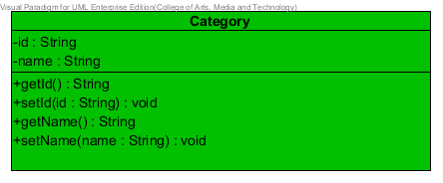

**Entities**

|  |  |  |  |
| --- | --- | --- | --- |
| **ID** | **Name** | **Description** | **Type** |
| 1 | id | stored id of the help place | string |
| 2 | name | stored name of the help place | string |

**Class name:** CategoryDAO

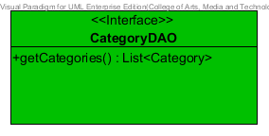

**Method details**

**Method name:** getHelpPlaces

public List<HelpPlace> getHelpPlaces ( )

**Description:** get help places from the database.

**Return:** List of the help place in database.

**Class name:** CategoryDAOImpl

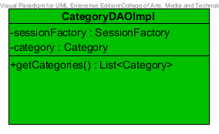

**Entities**

|  |  |  |  |
| --- | --- | --- | --- |
| **ID** | **Name** | **Description** | **Type** |
| 1 | sessionFactory | A thread-safe, immutable cache of compiled mappings for a single database | SessionFactory |
| 2 | category | Contained Category class for using method | Category |

**Method details**

**Method name:** getHelpPlaces

public List<HelpPlace> getHelpPlaces ( )

**Description:** get help places from the database by using session to query data.

**Return:** List of the help place in database.

**Class name:** CategoryService

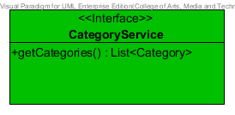

**Method details**

**Method name:** getHelpPlaces

public List<HelpPlace> getHelpPlaces ( )

**Description:** get help places from the database

**Return:** List of the help place in database.

**Class name:** CategoryService

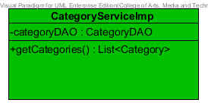

**Method details**

**Method name:** getHelpPlaces

public List<HelpPlace> getHelpPlaces ( )

**Description:** get help places from the database through getHelpPlaces method of CategoryDAO class.

**Return:** List of the help place in database.

**Class name:** Province

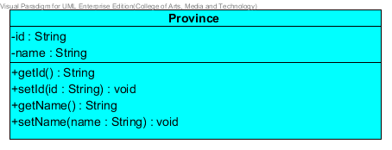

**Entities**

|  |  |  |  |
| --- | --- | --- | --- |
| **ID** | **Name** | **Description** | **Type** |
| 1 | id | stored id of the help place | string |
| 2 | name | stored name of the help place | string |

**Class name:** ProvinceDAO

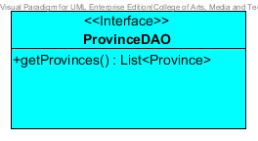

**Method details**

**Method name:** getHelpPlaces

public List<HelpPlace> getHelpPlaces ( )

**Description:** get help places from the database.

**Return:** List of the help place in database.

**Class name:** ProvinceDAOImpl

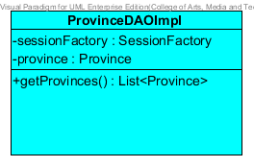

**Entities**

|  |  |  |  |
| --- | --- | --- | --- |
| **ID** | **Name** | **Description** | **Type** |
| 1 | sessionFactory | A thread-safe, immutable cache of compiled mappings for a single database | SessionFactory |
| 2 | province | Contained Province class for using method | Province |

**Method details**

**Method name:** getHelpPlaces

public List<HelpPlace> getHelpPlaces ( )

**Description:** get help places from the database by using session to query data.

**Return:** List of the help place in database.

**Class name:** ProvinceService

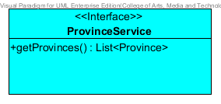

**Method details**

**Method name:** getHelpPlaces

public List<HelpPlace> getHelpPlaces ( )

**Description:** get help places from the database

**Return:** List of the help place in database.

**Class name:** ProvinceServiceImpl

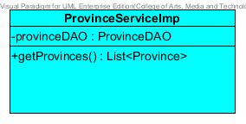

**Method details**

**Method name:** getHelpPlaces

public List<HelpPlace> getHelpPlaces ( )

**Description:** get help places from the database through getHelpPlaces method of ProvinceDAO class.

**Return:** List of the help place in database.